I. Document Change log
Date | Version | Description | Author
12/30/2025 | 1.0 | Created document | Diep Tu Huy
1/1/2026 | 1.1 | Add Function/Non-Functional Requirement | Tran Thao Nhi
1/1/2026 | 1.2 | Add DFD Level 0 | Diep Tu Huy
1/2/2026 | 1.3 | Add DFD Level 1 | Diep Tu huy
1/3/2026 | 1.4 | Add Usecase Diagram | Nguyen Thi Quynh Nhu
1/3/2026 | 1.5 | Add Usecase Description | Nguyen Thanh Huy
1/4/2026 | 1.6 | Add Class Diagram | Tran Tan Phat
1/4/2026 | 1.7 | Add Data Model | Tran Thao Nhi
1/5/2026 | 1.8 | Add Data Model | Tran Tan Phat
1/5/2026 | 1.9 | Add DFD Level 2 | Diep Tu Huy
1/6/2026 | 1.10 | Add UI Design | Nguyen Thanh Huy

Library Management System (LMS)

1. Functional Requirements

1.1 User Management
Login/Logout
- Users log in using their username and password
- The system supports secure logout
- The system displays an error message if the login information is incorrect

Account Management (Administrator)
- Create new accounts for different roles
- Update user account information
- Suspend or reactivate user accounts
- Delete user accounts from the system
Access Control
- The system automatically classifies and restricts functions based on roles
- Administrator: Full system management privileges
- Librarian: Manage books, process borrow/return transactions, manage fines
- Member: Can only search for books, borrow/return books, view personal history

1.2 Book Management
Add New Books (Librarian/Administrator)
- Enter complete book information: Book ID, Title, Author, Publisher, Publication Year, Category, ISBN, Quantity
- The system checks for duplicate ISBN or Book ID
Update Book Information (Librarian/Administrator)
- Edit information for existing books in the system
- Update book quantity when new copies are added
Delete Books (Librarian/Administrator)
- Remove books from the catalog when necessary
- The system verifies if the book is currently borrowed before deletion
Search Books (All users)
- Search by: Title, Author, Category, ISBN
- Display results with full information and available quantity

1.3 Borrowing and Returning Books
Borrow Books (Member)
- Members select available books to borrow
- The system automatically records: Borrow Date, Due Date (typically 14 days later)
- Automatically decreases the available quantity in inventory
- Borrowing Restrictions
Prevent borrowing when no copies are available
- Limit the number of books borrowed simultaneously (e.g., maximum of 5 books)
- Check if the member has unpaid fines before allowing new borrowings
Return Books (Member/Librarian)
- Record the actual return date
- Automatically increase the available quantity in inventory
- Automatically calculate fines if returned past the due date

1.4 Fine Management
Automatic Calculation
- The system automatically calculates fines based on the number of overdue days
- Stores fine information along with the borrowing transaction
Track and Process Fines (Librarian)
- View a list of unpaid fines
- Mark fines as paid when the member settles the payment
- Generate statistics on total fines over a period

1.5 Reports and Statistics
Reports for Librarian/Administrator
- List of currently borrowed books
- List of overdue books not yet returned
- List of active members
- Borrowing statistics by book/category
- Fine revenue statistics
System Statistics (Administrator)
- Number of users by role
- Total number of books in inventory
- Percentage of books currently on loan
- System activity over time

2. Non-Functional Requirements

2.1 Performance
- The system responds to user requests within 3 seconds under normal load
- Supports at least 100 concurrent users
- Page load and transaction processing time under 2 seconds

2.2 Security
- Password Encryption: User passwords are encrypted before storage
- Access Control: Detailed permission management based on user roles
- Data Protection: Prevent unauthorized access to the database
- Session Security: Automatic logout after a period of inactivity

2.3 Usability
- Intuitive, user-friendly interface for all user types
- Clear menu structure with logical grouping of functions
- Specific, easy-to-understand error messages and guidance
- Support for quick searches with smart filters

2.4 Reliability
- Ensures data consistency in all transactions
- Graceful error handling without data loss
- System operates stably 24/7 with minimal downtime
- Automatic periodic data backup

2.5 Maintainability
- Modular Architecture: Easy to add/remove features without affecting the system
- Clean Source Code: Fully documented, with meaningful variable and function names
- Easy Debugging: Detailed logging mechanism for system activities
- Scalability: Designed to allow scaling of user numbers and data volume

3. Data Flow Diagram (DFD)

3.1 Level 0
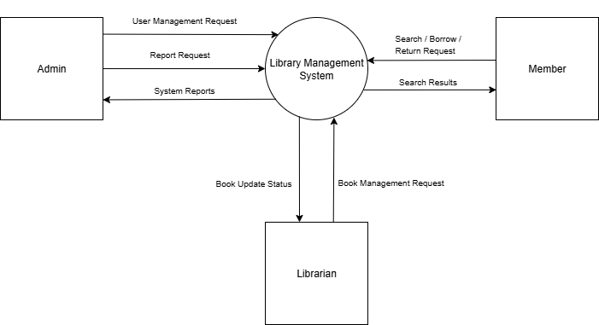

3.2 Level 1 DFD
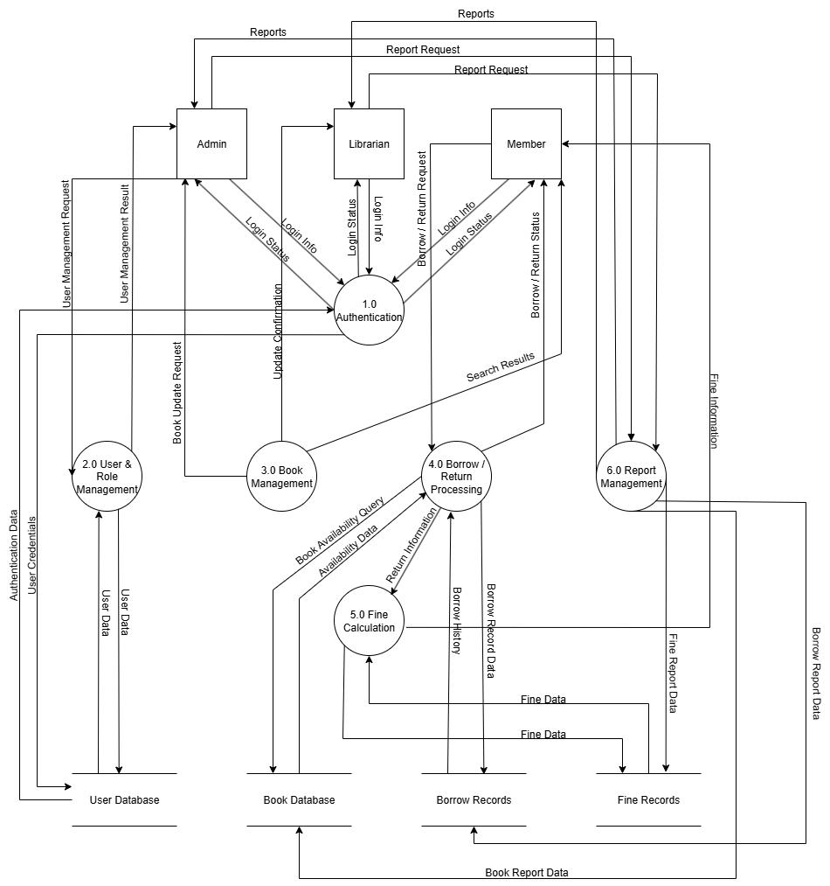

3.3 Level 2 DFD
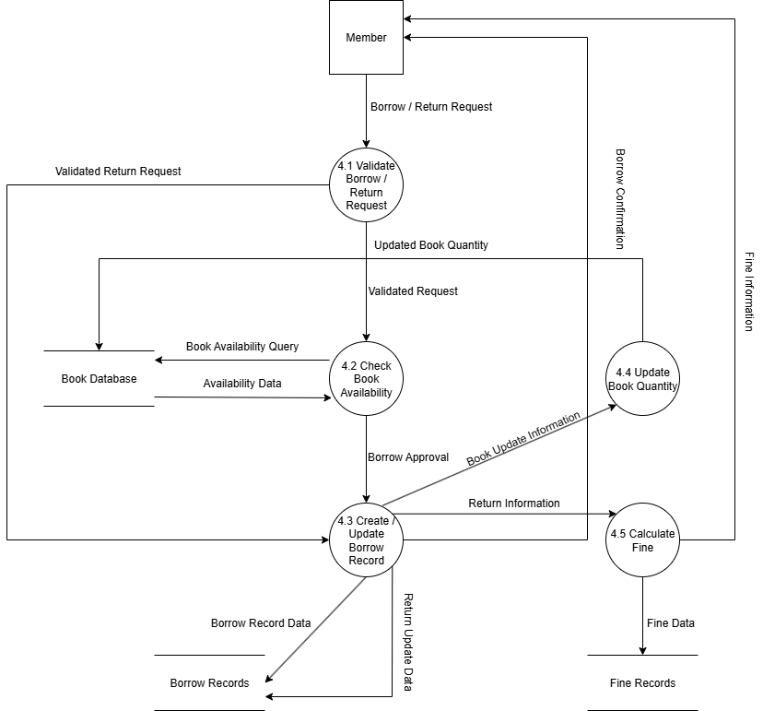

4. Use Case Diagram

4.1 Diagram overview
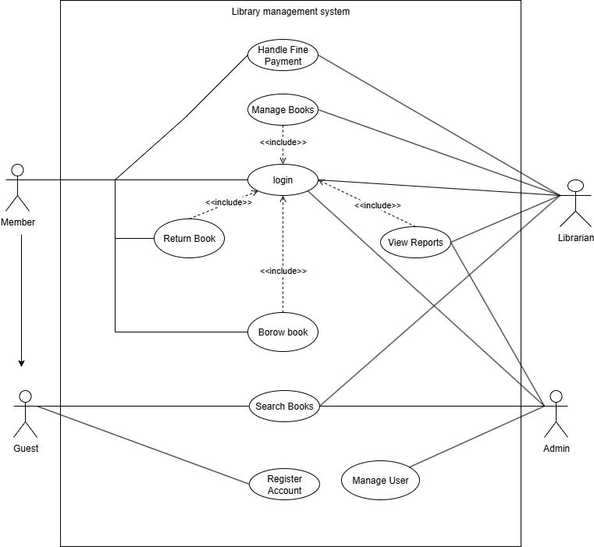

List of Actors
No. | Actor | Meaning
1 | Guest | Unregistered user who can only search for books and register for an account.
2 | Member | Registered user (Student/Faculty) who can borrow books, return books, and view personal history.
3 | Librarian | Library staff responsible for managing books, processing transactions, and handling fines.
4 | Admin | System administrator with full privileges to manage user accounts and system settings.

List of Use Cases
No. | Uses Case main | Note (Group)
1 | Login | Authentication
2 | Register Account | Authentication
3 | Search Books | Book Management
4 | Manage Books | Book Management
5 | Borrow Books | Circulation
6 | Return Books | Circulation
7 | Handle Fine Payment | Fine Management
8 | View Reports | Reporting
9 | Manage User | User Management

4.2 Use Case: Login

Summary
This use case allows all users (Member, Librarian, Administrator) to access the system. It authenticates credentials and checks for account lock status before granting access.

Flow of Events
Main Flow
- The use case starts when the user accesses the Login screen.
- The user enters their Username and Password.
- The system validates the credentials against the database.
- Include: The system performs a Lock User Account check to ensure the account is not currently suspended.
- If valid and active, the system grants access and redirects the user to their respective dashboard.

Alternate Flows
Invalid Credentials: The system displays an error message "Incorrect username or password" and asks the user to retry.
Account Locked: If the account status is "Locked", the system denies access.

Special Requirements
Passwords must be encrypted before storage and comparison.

Preconditions
The user is not logged in.

Postconditions
The user session is established.

Extension Points
Change Password: Users may choose to change their password upon logging in.

4.3 Use Case: Register Account

Summary
This use case allows a Guest to register for a new Member account to start using library services.

Flow of Events
Main Flow
- The Guest selects the "Register" option on the landing page.
- The system displays the registration form.
- The Guest enters the required personal information (Name, Email, etc.).
- The system validates the input format.
- Extend: The system triggers Create User Account to save the new record in the database.
- The system displays a success message.

Alternate Flows
Existing Account: If the email already exists, the system notifies the Guest.

Special Requirements
None.

Preconditions
The user is a Guest (not logged in).

Postconditions
A new Member account is created in the database.

4.4 Use Case: Search Books

Summary
This use case allows all users (Guest, Member, Librarian, Admin) to search for books in the library catalog using various criteria.

Flow of Events
Main Flow
- The user selects the "Search Books" function.
- The user enters a keyword.
- Extend: The user may choose specific filter criteria:
+ Search by Title
+ Search by Author
+ Search by Category
+ Search by ISBN
- The system queries the database.
- The system displays a list of matching books.

Special Requirements
None.

Preconditions
The system database is accessible.

Postconditions
Search results are displayed to the user.

4.5 Use Case: Manage Books

Summary
This use case allows Librarians or Admins to maintain the book catalog, including adding new books or updating existing ones.

Flow of Events
Main Flow (Add New Book)
- The Librarian selects "Add New Book".
- The Librarian enters book details (Title, ISBN, Quantity, etc.).
- Include: The system performs Check Duplicate ISBN to ensure uniqueness.
- Include: The system performs Validate Book Information.
- The system saves the new book to the database.

Special Requirements
None

Alternate Flows
Edit/Remove (Extension Points): The Librarian can select a book to Update Book Information, Update Book Quantity, or Remove Book.
Remove Book Constraint: If "Remove Book" is selected but the book is currently borrowed, the system preven5.4 Preconditions
User is logged in as Librarian or Admin.

Preconditions
User is logged in as Librarian or Admin.

Postconditions
The book database is updated.

4.6 Use Case: Borrow Books

Summary
This use case describes the process of checking out a book. It enforces business rules regarding inventory and borrowing limits.

Flow of Events
Main Flow
- The Member (or Librarian) initiates the borrowing process for a book.
- Include: The system executes Check Book Availability to verify the book is in stock.
- Include: The system executes Check Member Borrow Limit to ensure the member has not exceeded their quota.
- The system creates a Borrow Record with the current date.
- The system updates the book status and decrements the inventory count.
- The system confirms the transaction.

Alternate Flows
Unavailable/Limit Reached: If the book is out of stock or the member limit is reached, the system denies the request.

Special Requirements
Transaction processing must ensure data consistency.

Preconditions
Member is logged in and eligible to borrow.

Postconditions
Inventory is updated; Borrow Record is created.

4.7 Use Case: Return Books

Summary
This use case handles the return of books and automatically checks for overdue status to calculate fines if necessary.

Flow of Events
Main Flow
- The user scans the book to return.
- The system retrieves the active Borrow Record.
- The system updates the Return Date.
- Include: The system performs a Check Overdue verification.
- If not overdue, the system marks the book as "Available" and increments the inventory.

Alternate Flows
Overdue Return (Extension Point): If the book is returned late (Check Overdue is true), the use case extends to Calculate Fine. The system calculates the penalty and records it.

Special Requirements
None

Preconditions
The book was previously borrowed.

Postconditions
Book is returned to inventory. Fine is recorded if applicable.

4.8 Use Case: Handle Fine Payment

Summary
This use case allows the Librarian to process fine payments for Members with outstanding debts.

Flow of Events
Main Flow
- The Librarian accesses the View Unpaid Fines function for a Member.
- The system displays the total outstanding amount.
- The Librarian selects Confirm Fine Payment after receiving the payment.
- Include: The system triggers Make as Paid.
- The system updates the fine status to "Paid" in the database.

Special Requirement
None

Preconditions
Member has unpaid fines.

Postconditions
Fine status is updated to Paid.

4.9 Use Case: View Reports

Summary
This use case allows Administrators and Librarians to generate and view various system reports.

Flow of Events
Main Flow
- The user selects the "Generate Reports" dashboard.
- The user chooses a specific report type.
- Include: The system can generate specific reports such as:
    - + View User List
    - + Report on Locked User Accounts
    - + Report on User Role
- Alternatively, the Admin can view View System Usage Statistics.
- The system retrieves data and displays the report.

Special Requirements
None

Preconditions
User is logged in with appropriate privileges (Admin or Librarian).

Postconditions
The requested report is displayed.

4.10 Use Case: Manage User

Summary
This use case allows the Administrator to manage user accounts within the system.

Flow of Events
Main Flow
- The Administrator selects the "Manage User Accounts" function.
- The Administrator selects a specific user account.
- The Administrator performs an action. This use case extends to:
+ Create User Account: Add a new Librarian or Admin.
+ Lock User Account: Suspend a user.
+ Unlock User Account: Restore access.
+ Delete User Account: Remove a user.
+ Assign User Role: Change user permissions.
- The system executes the action and updates the database.

Special Requirements
None

Preconditions
User is logged in as Administrator.

Postconditions
User account status is modified.

5. Class Diagram
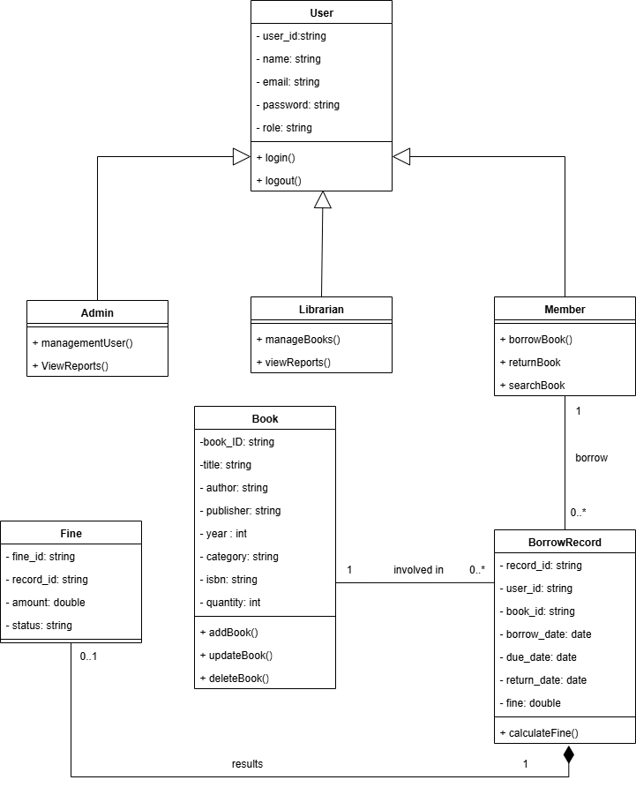

6. Data Model – Diagram Overview
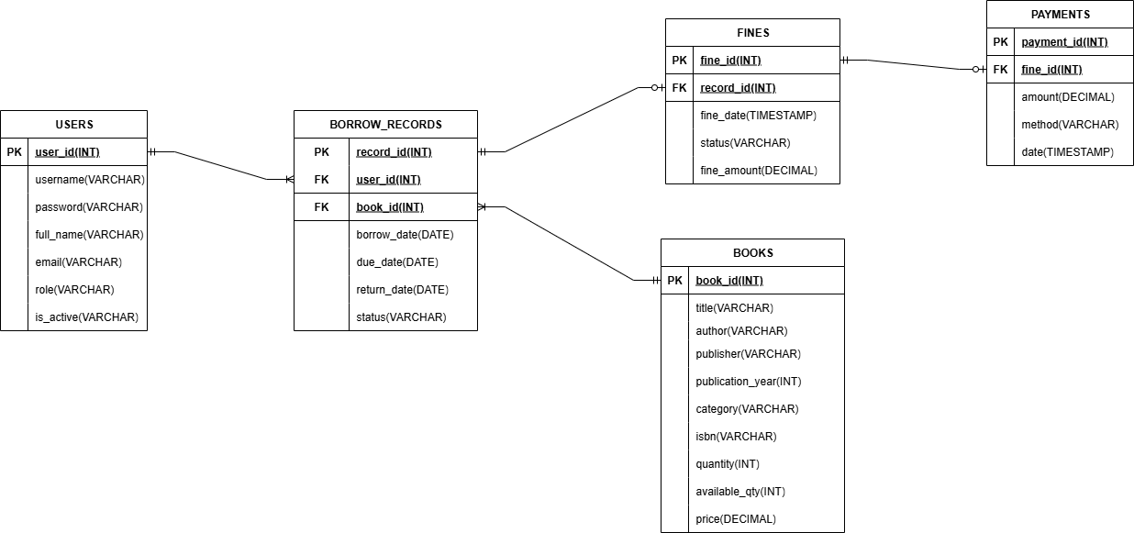

7. Interface Design Description

7.1 Login Interface

Description
The Login Interface allows users to authenticate and access the system based on their assigned roles.

Main Components
- Username input field
- Password input field
- Login button
- Error message area (displayed when login fails)

Behavior
- Users must enter a valid username and password to log in.
- The system validates the credentials against the User Database.
- Upon successful login, users are redirected to the Dashboard Interface corresponding to their role.
- If authentication fails, an error message is displayed.

7.2 Dashboard Interface

Description
The Dashboard Interface serves as the main navigation screen after login. The displayed features depend on the user role.

Main Components
- Navigation menu (role-based)
- Summary information (e.g., number of borrowed books, overdue books)
- Quick access buttons to main functionalities

Role-Based Access
- Administrator:
  - User Management
  - Book Management
  - Reports and Statistics
- Librarian:
  - Book Management
  - Fine Management
  - Reports
- Member:
  - Search Books
  - Borrow Books
  - Return Books
  - View Borrowing History
  - View Fines

7.3 Book Management Interface

Description
The Book Management Interface allows administrators and librarians to manage book information in the library.

Main Components
- Book list table displaying:
  - Book ID, Title, Author, Category, Quantity
- Search bar (search by title, author, category, ISBN)
- Add Book button
- Edit Book button
- Delete Book button

Behavior
- Authorized users can add new books by entering required book information.
- Existing book records can be updated or removed.
- Search results are displayed dynamically based on user input.

7.4 Borrow / Return Interface

Description
The Borrow / Return Interface enables members to borrow available books and return previously borrowed books.

Main Components
- List of available books
- Borrow button
- List of borrowed books
- Return button
- Borrowing details (borrow date, due date, return date)

Behavior
- The system checks book availability and borrowing limits before allowing borrowing.
- Upon borrowing, the system records the transaction and updates book quantity.
- When returning a book, the system updates the return date and triggers fine calculation if overdue.

7.5 Fine Management Interface

Description
The Fine Management Interface allows librarians to manage fines and members to view their fine information.

Main Components
- Fine list table (borrow record, fine amount, status)
- Fine status indicator (Paid / Unpaid)

Behavior
- The system automatically calculates fines for overdue returns.
- Librarians can view and manage unpaid fines.
- Members can view their own fine details.
Related Use Cases: Calculate Fine, View Fine Information
Related DFD Process: Fine Calculation Processing (Process 5.0)

7.6 Report Interface

Description
The Report Interface provides reporting and statistical information for administrators and librarians.

Main Components
- Report selection options:
  - Borrowed Books Report
  - Overdue Books Report
  - Active Members Report
- Display area for generated reports

Behavior
- Users can select a report type to view corresponding data.
- Reports are generated based on data stored in the system.
- Administrators can view overall system usage statistics.
Related Use Cases: View Reports
Related DFD Process: Report Management (Process 6.0)

